mUzima Biometrics OpenMRS
The objective of mUzima Biometrics Authentication system
Is to assist clinicians to be able to identify patients using OpenMRS

Software Specifications

The software should be able to run with android devices and interact with OpenMRS instance.
Approach
The biometric component for the mUzima project should be able to take on two approaches i.e.

- Face Recognition in identification and verification of patients
- Finger Print Reader for authentication, identification, verification for both patients and users of the mUzima platform.

The basic idea for the mUzima project is to be able to carry out the following tasks:

- Be able to identify, verify patients using fingerprints
- Authenticate users of mUzima platform as a security component on device
- Assist providers and clinicians in patient matching

Workflow

- A clinician or provider will Register a patient if the patient does not exist.
- The clinician will set the finger prints for that patient using a USB fingerprint reader
- The system will receive the finger print template and associate it to that patient in the database
- Clinician will verify patient by taking fingerprint of the patient .
- After successful verification the clinician will proceed to fill a form

Face Recognition
- Clinician takes a photo of patient using android device(phone,tab)
- Algorithm runs to assertain the stored photo and the current one taken
- Clinician proceeds to fill a form for the verified patient

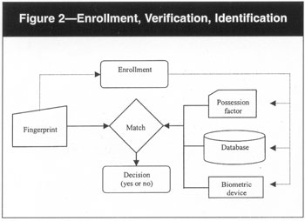

Requirement
- Fingerprint scanners/readers with SDK
- Android devices with camera app (face recognition)
- Module on OpenMRS –mUzima biometrics

Flow Of Events
- Patient downloaded to the phone as json string(Get patient object as json)
- Apk to provide a mechanism to initialize the biometric app page
- Clinician to set finger print of the downloaded patient with the real patient bio attributes
- Click on save/set to send/update database with exact bio data attributes of patient(post finger print template as string encoded base 64 to database in server)
- Sever to send notification to user that database has been updated
- Clinician to verify the finger print to identify and verify the patient(use a fingerprint matcher and finger print Extractor to compare the received template and the stored template on the server)
- Upon successful verification continue with mUzima to fill a form of the patient(If verification fails reset the finger print template of the patient by retaking them)

Muzima Module-Biomentrics

Enrollment Unit:

The enrollment module registers individuals into the biometric system database. During the phase, a biometric reader scans the individual’s biometric characteristic to produce its digital representation

Feature Extraction Unit:

The module processes the input sample to generate a compact representation called the template, which is then stored in a central database or a smartcard issued to the individual.

Matching Unit:

The module compares the current input with the template. If the system performs identity verification, it compares the new characteristics to the user’s master template and produces a score or match value (one to one matching). A system performing identification matches the new characteristics against the master templates of many users resulting in multiple match values (one too many matching).

Decision Maker:
The module accepts or rejects the user based on a security threshold and matching score

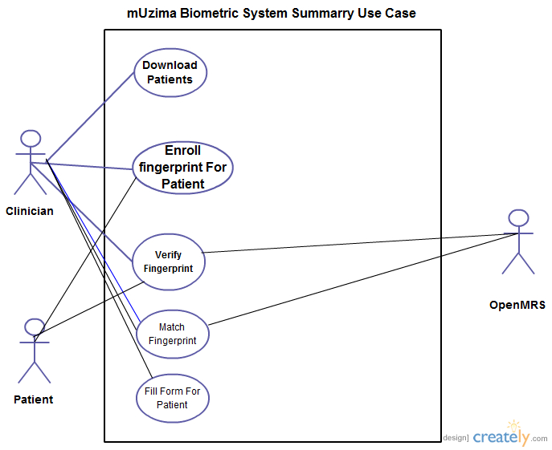

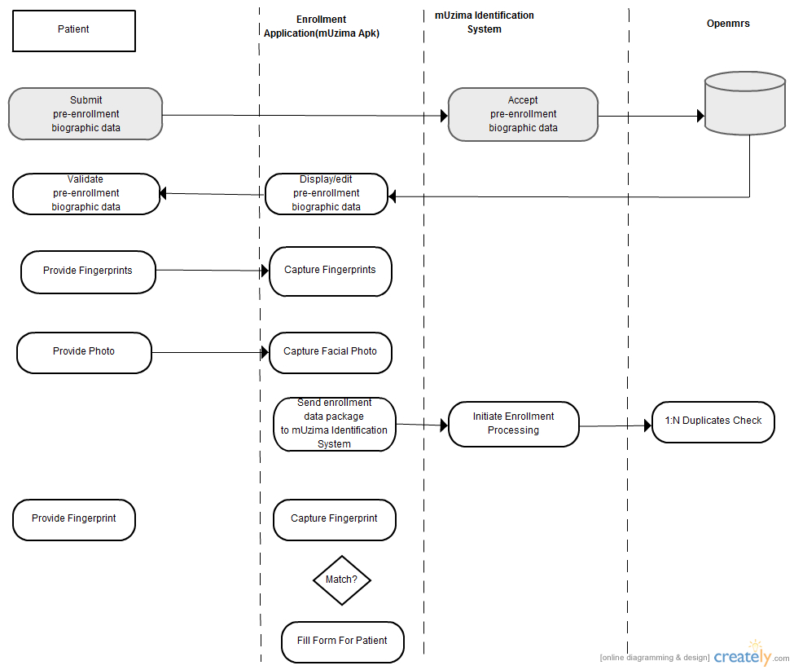

Development Strategy for the Database

- Add to the larger security focus area by supporting biometric identification via
advanced techniques for high speed search and retrieval

- Leverage existing pattern matching and recognition features to optimize biometric
vendor capabilities

- Actively seek partners to design, develop, and validate open APIs and performant index/search features
Fingerprint Example

Table creation
CREATE TABLE Employees (name VARCHAR2(128), employee_id INTEGER,
dept VARCHAR2(30), fingerprint_template RAW(1024));

Indexing the column
CREATE INDEX FingerprintIndex ON Employees(fingerprint_template)
INDEXTYPE IS FingerprintIndexType;

Retrieving and matching scores
SELECT name, Score(1)FROM Employees
WHERE
IdentifyMatch(fingerprint_template, <input>, 1) > 0;

Sample SDKs
- VeriFinger 6.7 Standard SDK is intended for PC-based or Android-based biometric application development. It includes Fingerprint Matcher and Fingerprint Extractor components, programming samples and tutorials, fingerprint scanner support modules and software documentation. The SDK allows the development of biometric applications for Microsoft Windows, Linux, Mac OS X and Android operating systems.

- VeriFinger 6.7 Extended SDK is intended for biometric Web-based and network application development. It includes all features and components of Standard SDK. Additionally, the SDK contains Fingerprint Client component and a ready-to-use matching server.

